Architecture Design

# Investment Analytics

|  |  |
| --- | --- |
| **Written By** | Sarthak Sethi |
| **Document Version** | 1.1 |
| **Last Revised Date** | 15/03/2023 |

**DOCUMENT CONTROL**

## Change Record:

|  |  |  |  |
| --- | --- | --- | --- |
| **Date** | **Version** | **Description** | **Author** |
| **14th Jan 2023** | 1.0 | Introduction, Architecture and deployment | Sarthak Sethi |
| **15th Jan 2023** | 1.1 | Final Version of Complete Architecture | Sarthak Sethi |

**Contents**

1. Introduction 04
   1. What is Architecture Design Document? 04
   2. Scope 04
2. Architecture 05
   1. Tableau Architecture 05
   2. Tableau Server Architecture 05
   3. Server Processes 06
3. Deployment 08
   1. Deployment options 09

# Introduction

## What is Architecture design document?

Any software needs the architectural design to represents the design of software. IEEE defines architectural design as “the process of defining a collection of hardware and software components and their interfaces to establish the framework for the development of a computer system.” The software that is built for computer-based systems can exhibit one of these many architectures.

Each style will describe a system category that consists of :

* A set of components (eg: a database, computational modules) that will perform a functionrequired by the system.
* The set of connectors will help in coordination, communication, and cooperation betweenthe components.
* Conditions that how components can be integrated to form the system.
* Semantic models that help the designer to understand the overall properties of thesystem.

## Scope

Architecture Design Document (ADD) is an architecture design process that follows a step-by- step refinement process. The process can be used for designing data structures, required software architecture, source code and ultimately, performance algorithms. Overall, the design principles may be defined during requirement analysis and then refined during architectural design work.

# 1 Architecture

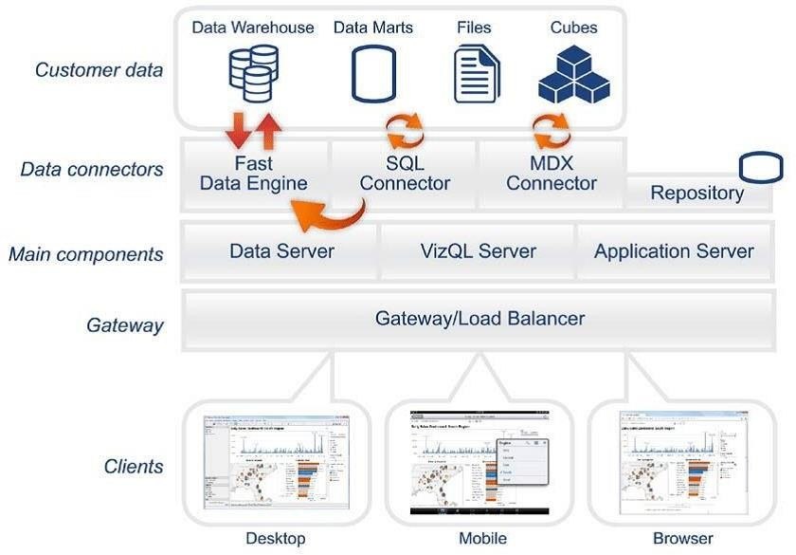

**2.2 Tableau Server Architecture**

Tableau has a highly scalable, n-tier client-server architecture that serves mobile clients, web clients and desktop-installed software. Tableau Server architecture supports fast and flexible deployments.

The following diagram shows Tableau Server’s architecture:

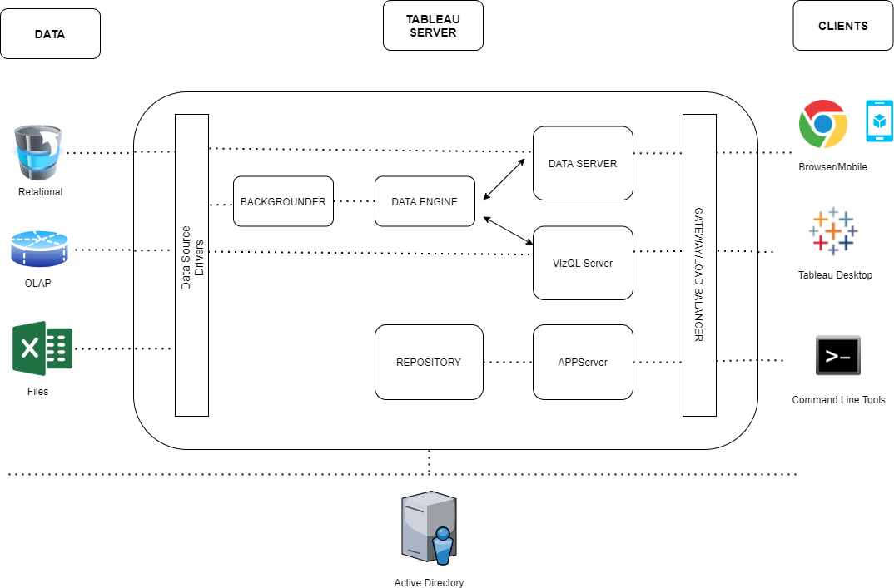

# 2.3 Tableau Server Processes

### 1. Gateway/Load Balancer

It acts as an Entry gate to the Tableau Server and also balances the load to the Server if multipleProcesses are configured.

**2) Application Server:-**

Application Server processes (wgserver.exe) handle browsing and permissions for the Tableau Server web and mobile interfaces. When a user opens a view in a client device, that user starts asession on Tableau Server. This means that an Application Server thread starts and checks the permissions for that user and that view.

### Repository:-

Tableau Server Repository is a PostgreSQL database that stores server data. This data includes information about Tableau Server users, groups and group assignments, permissions, projects, data sources, and extract metadata and refresh information.

### VIZQL Server:-

Once a view is opened, the client sends a request to the VizQL process (vizqlserver.exe). The VizQL process then sends queries directly to the data source, returning a result set that is rendered as images and presented to the user. Each VizQL Server has its own cache that can be shared acrossmultiple users

### Data Engine:-

It Stores data extracts and answers queries.

### Backgrounder:-

The backgrounder Executes server tasks which includes refreshes scheduled extracts, tasks initiated from tabcmd and manages other background tasks.

### Data Server:-

Data Server Manages connections to Tableau Server data sources

It also maintains metadata from Tableau Desktop, such as calculations, definitions, and groups.

# Deployment Description

## Deployment options in Tableau

Tableau’s analytics platform offers three different deployment options depending on your environment and needs. The below graphic shows each option at a glance:

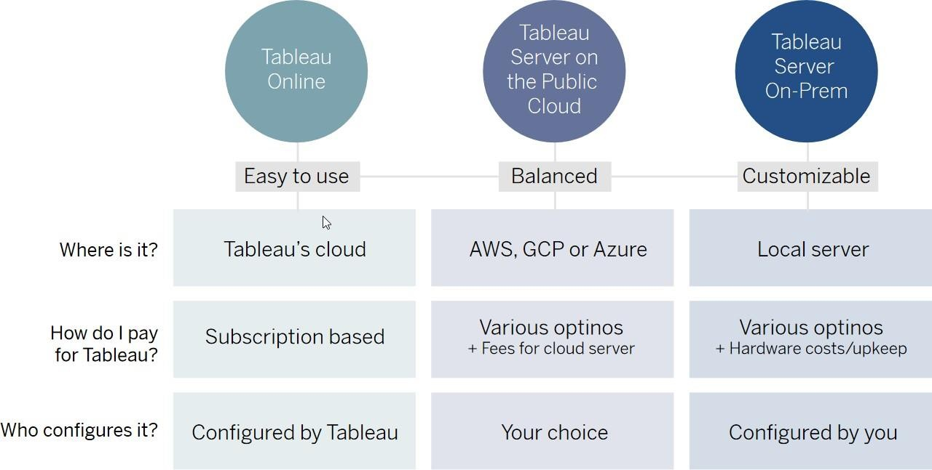

1. **Tableau Online** Get up and running quickly with no hardware required. Tableau Online is fullyhosted by Tableau so all upgrades and maintenance are automatically managed for you.
2. **Tableau Server** deployed on public cloud: Leverage the flexibility and scalability of cloud infrastructure without giving up control. Deploy to Amazon Web Services, Google Cloud Platform, or Microsoft Azure infrastructure to quickly get started with Tableau Server (on your choice of Windows or Linux). Bring your own license or purchase on your preferred marketplace.
3. **Tableau Server deployed on-premises**: Manage and scale your own hardware and software(whether Windows or Linux) as needed. Customize your deployment as you see fit.

The importance of prioritizing data and analytics cannot be overstated, especially in today's business landscape. Regardless of the size of your company, chances are you are already collecting data and using analytics to solve business problems, gain a competitive edge, and transform your enterprise.

As enterprise data continues to grow exponentially and database technologies become more advanced, the need for analytical skills has become increasingly crucial. To keep up with these developments, the most effective IT organizations have shifted their focus to enable self-service capabilities by deploying and managing Tableau at scale. They also work to unify disparate sources of data, organize it effectively, and provide business users and experts with the tools they need to create and access data-driven content.

By prioritizing data and analytics, businesses can make informed decisions that help them stay ahead of the competition and drive growth. It is an essential component of any successful enterprise transformation strategy, and organizations that do not prioritize it risk falling behind in today's rapidly evolving business landscape.

In addition to providing a competitive advantage, prioritizing data and analytics can also help organizations improve operational efficiency, reduce costs, and optimize their business processes. By analyzing data from various sources, businesses can identify areas of improvement, make data-driven decisions, and measure the impact of their initiatives.

Furthermore, data and analytics can help organizations stay on top of industry trends and adapt to changing market conditions. By monitoring customer behavior and preferences, businesses can tailor their products and services to better meet the needs of their target audience. They can also use data to identify new market opportunities and expand their customer base.

In today's digital age, data is increasingly being used to improve customer experience and build customer loyalty. By analyzing customer data, businesses can gain insights into customer preferences, buying patterns, and pain points, which can be used to create personalized experiences and targeted marketing campaigns. This not only

improves customer satisfaction but can also lead to increased sales and revenue.

Finally, prioritizing data and analytics can help organizations build a culture of innovation and continuous improvement. By empowering employees to make data- driven decisions and providing them with the necessary tools and resources, businesses can foster a culture of learning and experimentation. This can lead to the development of new products and services, improved processes, and a more agile and resilient organization.

In summary, prioritizing data and analytics is essential for businesses looking to stay ahead in today's rapidly evolving business landscape. It enables organizations to make informed decisions, gain a competitive edge, and drive growth and innovation. As the importance of data continues to grow, it is crucial for businesses of all sizes to invest in the necessary tools, skills, and resources to effectively collect, analyze, and leverage data.

## DASHBOARD-1

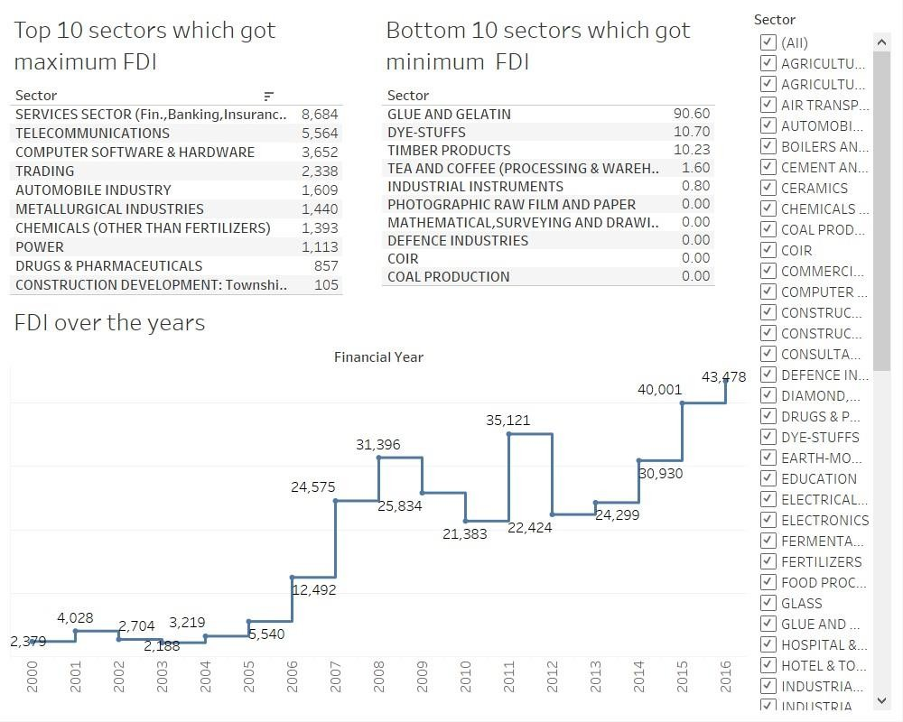

**DASHBOARD-2**

